# HackLab Club Toronto Inc.

Diversity and Inclusiveness Statement

Hacklab Club Toronto is a community that values and recognizes diversity, and defends and cultivates equitable experiences. We are committed not only to including marginalized voices and bodies, but also to actively fighting racism, sexism, and oppression in all its forms.

We welcome and advocate for the presence and contributions of all people regardless of their ability, age, body size, cultural background, education, ethnic origin, gender expression, gender identity, immigration status, language, marital status, nationality, physical appearance, political affiliations, race, religion, sexual orientation, sexuality, status as a parent, socioeconomic status, or other such factors.

Prejudice, oppression, and discrimination are detrimental to the health and growth of our community and the individuals who are a part of it. Supporting the visibility of our diverse lives enhances the experiences of all community members. We recognize and honor our differences and vigorously defend Hacklab as a safe and equitable space.

## Diversity Statement Quality

The terms we use to describe our experiences are always changing, and we are always learning. We are eager to maintain and defend the safety and inclusivity of this community moving forward.

If you feel that that something has been omitted or missing in this statement, or have ideas on how it can be improved, please engage the community through common methods and contribute by modifying this document and moving your modifications for adoption.

This document is a living document and is available for check-out and modification via GitHub @ <https://github.com/hacklabto>.

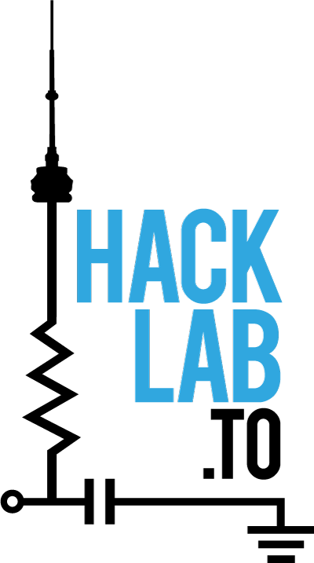

## Document History

|  |  |  |  |
| --- | --- | --- | --- |
| Version | Date | Author | Comment |
| 1.0.2017 | 17-Jan-2017 | Daria Juniper | Initial draft formatting and cut/paste from the Slack working group. |
|  |  |  |  |
|  |  |  |  |
|  |  |  |  |